Eggless Chocolate Cake No eggs no butter it should be very simple. However the amount and mixing requirement to be well-known down very prudently as it possibly will be turn sultry and not baked inside if imprecise. The flavor is no smaller than a gnome and can be served with a helping of choco - caramel sauce.

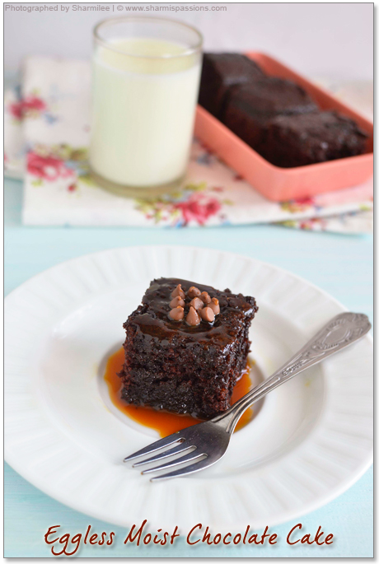

I've recommended this recipe to few friends, cousin they too tried & agreed with me about the taste. And finally it was certified by my niece, she liked it soo much, and when I heard that she took it to school daily till it got over I was on top of the world!! Am waiting for my lil one to taste it too.....though have given her few pinches of this cake, she was licking & didnt leave my fingers :)

**Eggless Chocolate Cake Recipe - Ingredients**

**"Slim" pill conquered India by storm (DailyWellness)**

Dry Ingredients: 1 and 1/2 cups 200 gms All-purpose flour (Maida), 3 tablespoon Cocoa powder   
1 teaspoon Baking soda, 1/8 teaspoon Baking powder as per required, Salt - 1/4 teaspoon, 3/4 cup Granulated Sugar 165 gms 2 tablespoon Chocolate Chips, Wet Ingredients: 1 cup Water about 250 ml, 1/2 tablespoon Vanilla essence, 1 tablespoon Lemon juice 1/4 cup Oil about 60 ml.

Bring water in a mingling dish insert all ingredients vanilla essence sugar lemon juice and oil. Assortment well checkout sugar completely dissolves. Save apart. Now take cover, burning beverage, baking and coco powder and select together double at least to make the flour, soda baking and coco powder is equally feast out, then slowly add selected flour mix to the damp components mixture may be in 2 sides generally mix in one way, break the pieces creating mildly mixture it, double in Choco marks and give a fast stir. Warm stove to 180 deg C for 10mins.Grease the pot with lard, scatter maida tap it so that meals on all parts. Decant the batter into the cake pot. Burn it at 180 deg C for 35-40mins plaid with a split if a fork injected comes out clean. Brand certain to cool at least for 10-15 mins and then reverse prudently and cut into parts.

